

**Bachelor/Master/Diploma Thesis**

## Framework for ASIP Development

Application Specific Instruction Set Processors (ASIP) are processors with an application specific instruction set, and they show a good trade-off between Application Specific Integrated Circuits (ASIC) and General Purpose Processors (GPP). ASIPs can be customized or optimized for a specific application to achieve better energy and speed benefits. This customization can be addressed at different architectural levels by defining customized instructions, including/excluding predefined blocks or setting processor parameters.

The ASIP design flow typically starts with analysing and profiling the targeted application, after which an ASIP is defined by specifying its instruction set, embedding required blocks or by configuring different architectural parameters. Then, to implement the ASIP, a synthesizable hardware description and a tool chain is created automatically. Using these tools and hardware description the ASIP is benchmarked and may be refined if optimization is not met.

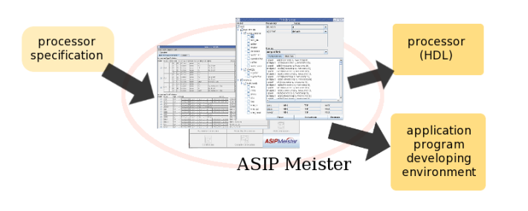

**Goal:**

The goal of this thesis is to gain experience with the state-of-the-art ASIP design tools, and then use different professional tools to benchmark the designed ASIP to compare cost & benefit in terms of performance, power, area etc.

In case of Master thesis, we can additionally select and application, for example H.264, and develop an ASIP for it. Some of the links for the ASIP tool that will be used are:

* <http://www-ise1.ist.osaka-u.ac.jp/lab/research/processor/?lang=en>
* <http://aranea.ics.es.osaka-u.ac.jp/dac2003/>
* <https://www.edacentrum.de/system/files/files/veranstaltungen/2005/date05/ubooth/descriptions/Description_sw_ASIP.pdf>

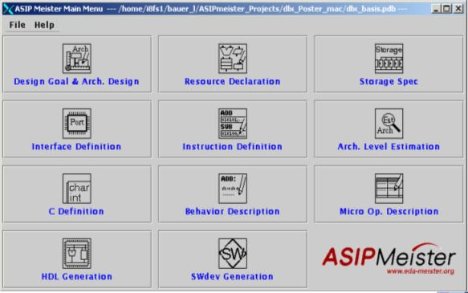

**Beneficial Knowledge:**

* C Language (Good)
* Assembly Language (Good)
* VHDL (Preliminary)

**Course of Studies:**

* Electrical Engineering
* Informatics/Computer Engineering

**Supervisor:**

M.Sc. Sajjad Hussain,

<http://ces.itec.kit.edu/~sajjad>

Dr. Ing. Lars Bauer,

<http://ces.itec.kit.edu/~bauer>

**Email:** {sajjad.hussain, lars.bauer}@kit.edu